Traditional Commerce Vs E Commerce
Dr.S.Nizar Ahmed
H.O.D &Asso.Prof.of Commerce
Al AmeenArts,Science& Commerce College
Hosur Road. BANGALORE 560027
Ph. No. +91 9449010786

Abstract:
Although both traditional commerce and e-commerce concern the buying and selling of goods and services, e-commerce performs a different way for marketing and purchasing. Traditional commerce usually consists of an interaction between salesperson and buyer in a place of business. E-commerce is usually done completely online and is impersonal. Due to the increased popularity and availability of Internet access many traditional small business are considering ecommerce as a valid and profitable sales channel. It is important to weigh carefully the differences between ecommerce and traditional commerce in order to decide if it would be a good fit for your business or just a costly mistake. As e-commerce provides fast and convenient method for market, a growing number of Indians are fast turning into full-time online shoppers, buying everything from books to apparel, home decor and electronic devices at the click of a button. As their tribe grows rapidly, top e-retailer are threatening to dwarf the revenues of brick-and-mortar rivals - at least in some categories for sure.

Full Paper:
Traditional Commerce
In simple terms, traditional commerce consists of marketing to reach potential customers, getting together with the customer in a place of business, agreeing on a sale, and making the exchange of goods and money. Common marketing techniques used to reach potential customers include mailings, phone calls and advertisements. Then the buyer and/or the salesman are the active parties involved in a sale and exchange. In one case, the buyer initiates the purchase by either going to the store to buy or calling on the phone and making an order. In another situation, the salesman goes to the home or place of business to make the sale, or he calls on the phone to make the sale. A third method combines action from both parties. The business' sales department mails a catalog or other material, and the customer then makes a purchase from the catalog. These methods all apply to business-to-consumer (B2C) as well as business-to-business (B2B) sales.
Different Kinds of “Traditional” Commerce Models
Not every commerce transaction is identical, and not every transaction is the same type of transaction. Roughly there are five types of commerce transaction offline.
Retail store
This is by far the most common commerce experience in American culture: you walk into a store that is stocked with merchandise for immediate sale — bookstores, grocery stores, hardware stores — and find what you want, then purchase it. You leave the store with the product, assuming immediate ownership.
Retail special order
When a retail store doesn’t stock the product you want, or is currently out of stock, you often have the option of special ordering the product. If a bookstore doesn’t care a small press book title that you want, and the title is in print, you can usually special order the title from the store; the store locates the product, buys it, then resells it you. Delayed gratification, but you have the advantage of dealing with a merchant face-to-face. I would consider rain checks in this same category.
Catalogue store
Smaller towns sometimes have catalogue stores, where a large merchant doesn’t see a local demand to keep a store stocked with merchandise, so they instead provide a storefront where people can come in and look at catalogues, and order from a company representative.
Phone order from a catalogue
Mail order catalogues, with their operators standing by, have been around longer than the Internet. While you can’t touch and feel the merchandise prior to ordering, you can at least speak with a live person when placing the order.
Bargaining
This form of commerce transaction is prevalent in India and world wide.
While these may be different types of commerce transactions, they are all clearly related. They share elements like the roles involved (seller and buyer), steps in the transactions (price must be agreed upon, money must change hands), and underlying concepts (the value of this merchandise to me, do I know this merchant?). Ultimately, these different transactions differ only slightly on some few elements, with the bulk of the transaction adhering to the internal models that we have built for what commerce is like.
In fact, based on our experience, we build frameworks to describe these transactions, with steps and meaningful elements, and we use these frameworks to understand every new commerce transaction in which we engage. These frameworks are called schemas, and we use these schemas to make sense of ecommerce web sites when we take our shopping online.

Characteristics of Traditional Commerce.
Identity. Customers can easily authenticate the identity of a merchant simply by walking into a bricks-and-mortar store. Stores can be members of a community and neighborhood; they can be part of customers’ daily experience. There is a concreteness about a physical store that no amount of HTML will ever match.
Immediacy. Customers can touch and feel and hold the merchandise. Tactile cues can drive the decision to buy. A transaction that is face-to-face is usually unmediated: your communication with the merchant is not in the hands of a third party or technology (as with ordering by phone).
Value. The item at the center of the commerce transaction — the product, service, or property that is to be sold/bought — has some kind of value. Its price is determined and validated through the performance of the transaction. The seller agrees to a selling price, and the buyer agrees to a buying price. The value of an item, especially the relative value an item has for the buyer, is much easier to appraise if that item is close at hand.
Discourse. Customers can converse with the merchant face-to-face; unmediated conversation is basic to human communication. People want the feedback available from non-verbal behavior, which forms a large part of our judgment process.
Community. Customers can interact with other customers and gain feedback about the merchant from other customers, as well as by observing the merchant interacting with other customers.

Privacy. Customers can make purchases anonymously with cash; they usually don’t have to give their name or address. They don’t usually have to worry about what a store will do with their personal information, although this is becoming more of an issue with various recent attempts by lawyers to access private sales and rental records. Privacy is often a measure of how much of his or her identity a buyer wants to invest in a transaction; sometimes, we just want to quietly make our purchase and leave with it.
An online commerce customer faces mediation in every element and at every stage of the commerce transaction. Customers can’t see the merchant, only the merchant’s website; they can’t touch the merchandise, they can only see a representation; they can’t wander a store and speak with employees, they can only browse HTML pages, read FAQs, and fire off email to nameless customer service mailboxes; they can’t explore the store’s shelves and product space, they can only search a digital catalog. A customer at an online commerce site lacks the concrete cues to comfortably assess the trustworthiness of the site, and so must rely on new kinds of cues. The problem for the online customer is that the web is new — to a large sector of the online audience — and online commerce seems like a step into an unknown experience.

Online commerce
E-Commerce, online commerce or e-commerce uses e marketing to reach potential customers. There are two forms of E-Marketing: push-marketing and pull-marketing. Push marketing consists of sending out emails and e-zines, as well as posting online ads on various websites. It is pushing information to the people. Pull marketing is having a website where customers seek out information about your products. Social marketing is also used in pull marketing. The buying and selling is similar to the traditional mail order catalog method, except that orders can be performed online from a website. The business' sales department posts a Web site with an online catalog. The buyer then selects items from the online catalog and makes the purchase, either online or by phoning or mail order. A valid credit card is required to make a purchase. Although the buyer is really using an online catalog, the metaphor of browsing a store with a shopping cart is often used in e-commerce. This allows the customer to put items in the shopping cart to hold until checkout or when the purchase is finally made. These methods also apply to both B2C and B2B sales.
E-commerce businesses may employ some or all of the following:
- Online shopping web sites for retail sales direct to consumers.
- Providing or participating in online marketplaces, which process third-party business-to-consumer or consumer-to-consumer sales
- Business-to-business buying and selling
- Gathering and using demographic data through web contacts and social media
- Business-to-business electronic data interchange.
- Marketing to prospective and established customers by e-mail or fax (for example, with newsletters)
- Engaging in retail for launching new products and services

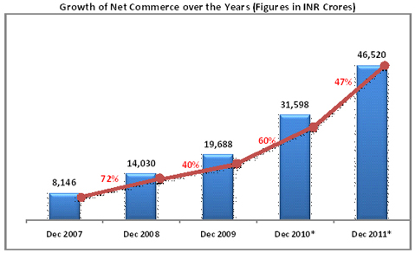

The Process of ecommerce
The consumer browses the catalog of products featured on the sites and selects items to purchase. The selected items are placed in the electronic equivalent of a shopping cart and provide a bill and ship to address for purchase and delivery.
Advantages of e-commerce
- More product and services: EC provides with more choices ; they can select from many vendors and from more products.
- Cheaper products: EC frequently provides consumer with less expensive products and services by allowing them to shop in many places and conduct quick comparisons.
- No middleman: there is a direct contact with the costumers in e-commerce through Internet without any intermediation. Companies can now focus more on specific customers by adopting different one.0…00 v v01000-to-one marketing strategy.
- You can shop anywhere in the world.
- Easy access 24 hours a day

Disadvantages of e-commerce

- Not everyone is connected to the internet
- There is the possibility of credit card number theft (there is an increase amount of fraud in internet)
3.There is no guarantee for purchased good as online shopping (because .productis intangible until the product is at hand)

E-commerce also has negative effects on both consumers and retailers :
Privacy
It is easy to collect a lot of personal information from a consumer using an e-commerce website, sometimes too easy. Since all online transactions are recorded, it's relatively easy to create an online profile of the buyer, and use that to send targeted advertisements. However, many will agree that this is an intrusion on a consumer's right to privacy, and it's something that is heavily regulated on many countries. This means small businesses aiming to establish an online presence using e-commerce need to be aware of the legislation that applies, as mistakes can be costly both in terms of fines and customer trust.
Security
Another negative effect of e-commerce is its effect on consumers' security. Online transactions are inherently more insecure than those conducted in person because there's no way to guarantee that the person making the payment is the actual owner of the credit card used. At the same time, when the customer inputs the payment information they risk a third party intercepting it if the website doesn't comply with the adequate security measures, giving rise to credit card fraud and identity theft. Merchants need to be aware of the risks electronic transactions carry, and work towards securing the systems to the highest standards.
Price Wars
Merchants used to selling at their shop may often find selling online an extremely competitive marketplace. Their products are displayed alongside competitive offers, often from different countries or bigger retailers with access to better wholesale prices. This can affect the retailer negatively, as they cannot sell as much as they expected to actually make a profit, or the consumer's when online stores cut corners in order to become more competitive or products are purchased from illegitimate retailers because they had the best price.
Returns And Complaints
Selling online means usually a higher return rate on products than when the purchase was conducted in person. This is due partly to the fact that customers haven't seen the goods in person prior to purchase, but also to the fact that many online shoppers buy things on impulse, and by the time they receive them at their home they have changed their mind and make use of favorable return policies. While a big retailer would have no problem accommodating this, it can be highly disruptive for a small business with limited stock management.
Selling online means learning new ways of dealing with customers.marketing your products and fulfilling your orders, but the benefits are great. You can keep your costs lower, reach a wider audience and do business 24/7, having time to focus on improving your products and services and your customer experience instead of being on the store floor waiting for clients. Some products sell better online than others: selling jewellery for cash online is much easier than trying to sell houses or cars. However, having an online store can increase the customers on your traditional commerce as well, as people are now able to find you online and see what products you are offering.

E-Commerce Vs. Traditional Commerce
Due to the increased popularity and availability of Internet access many traditional small business are considering ecommerce as a valid and profitable sales channel. However, ecommerce and traditional commerce are very different, and it's important to weight carefully the differences between ecommerce and traditional commerce in order to decide if it would be a good fit for your business or just a costly mistake.
Direct Interaction
Traditional commerce is often based around face to face interaction. The customer has a chance to ask questions and the sales staff can work with them to ensure a satisfactory transaction. Often this gives sales staff an opportunity for upselling, or encourages the client to buy a more expensive item or related items, increasing the shop profits. On the other hand, ecommerce doesn't offer this benefit unless features such as related items or live chats are implemented.
Lower Costs
Ecommerce is usually much cheaper than maintaining a physical store in an equally popular location. Compared with costs such as commercial space rent, opening an online store can be done at a fraction of the price for less than $50 per month. This can prove invaluable for small business owners who don't have the startup capital to rent prime retail space and staff it to be able to sell their goods.
Reach
With an online shop you can do business with anybody living on a country you are able and willing to send mail to, unlike traditional commerce where you are restricted to people who actually come to your shop. This also opens the door to many other forms of marketing that can be done entirely online, which often results in a much larger volume of sales and even foot traffic to the store. An online store has no capability limits, and you can have as many clients as your stock can serve.
Returns Rate
In a traditional store, the customer will be purchasing the product in person, which has some benefits for both the him and the store. The customer will be able to touch and check the items, to make sure they are suitable, and even try them on, which reduces the number of returned items or complaints due to an item not being as advertised on a catalogue. or promotional leaflet. Expect a significantly higher rate of returns if you start trading online, as many will just order and try the items at home, and won't hesitate to return them as they can do it by post without having to talk with anybody in person.
Credit Card Fraud
The remote nature of Ecommerce makes much more difficult to detect fraud, which means stores can lose money due to fraud. While traditional commerce is not totally secure, it's easier for a sales attendant to verify that the person buying something is actually the owner of the credit card, by asking for photographic ID. However, the fight against card fraud is well underway and banks and responsible ecommerce owners work together to verify that all card use is legitimate.
Selling online means learning new ways of dealing with customer , marketing your products and fulfilling your orders, but the benefits are great. You can keep your costs lower, reach a wider audience and do business 24/7, having time to focus on improving your products and services and your customer experience instead of being on the store floor waiting for clients. Some products sell better online than others selling jewelry for cash online is much easier than trying to sell houses or cars. However, having an online store can increase the customers on your traditional commerce as well, as people are now able to find you online and see what products you are offering.
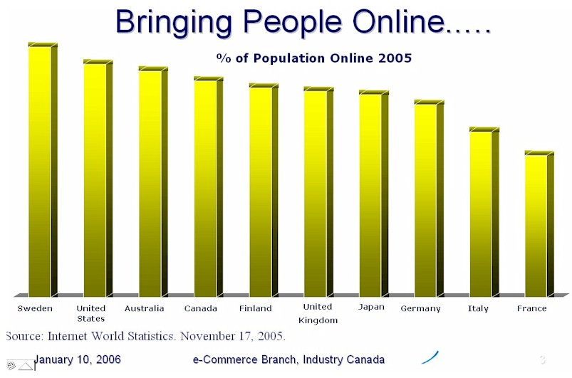

Conclusion
In the 21st century, the rapid development of information technology and the rapid increase in information exchange have brought new drives and innovative ideas to the whole society. The wide adoption of information technology by the community has led to great changes. These changes are not simply in the context of data processing or computing. They are changes which affect how we communicate with each other, how we organise our daily activities, how we educate the younger generation, and how we run business. The development and wide adoption of information technology, computer network and Internet have transformed the mode of operation of many businesses, and at the same time have brought along unprecedented business opportunities. Businesses are now able to conduct transactions across geographical boundaries, across time zones and at a high efficiency. E-Commerce has become the market trend of the Century.Once in your shop, either physically or online, your clients and potential customers need to be convinced to buy from you. Once they’re in your shop, you want them to shop ‘til they drop! The quality of the service and the shopping experience on the whole all play a part. You can focus your pitch on any number of topics: unique products, your wide range of products, detailed information, value for money (which equals a loyal client base) etc.

REFERENCES
Asim Ansari, OdedKoenigsberg and Florian Stahl. (2013) Modeling Multiple Relationships in Social Networks.
Norris I Bruce, Natasha Zhang Foutz and CerenKolsarici.(2013) Dynamic Effectiveness of Advertising and Word of Mouth in Sequential Distribution of New Products.
Journal of Marketing Research 49:4, 469-486.
Online publication date: 1-Aug-2012.
Journal of Marketing Research 48:4, 713-728.
Online publication date: 1-Aug-2011.
Robert W Palmatier, Rajiv P Dant, DhruvGrewal and Kenneth R Evans. (2013) Factors Influencing the Effectiveness of Relationship Marketing: A Meta-Analysis.
Journal of Marketing 70:4, 136-153.
Online publication date: 1-Oct-2006.
Andrew T Stephen and Jeff Galak. (2013) The Effects of Traditional and Social Earned Media on Sales: A Study of a Microlending Marketplace

